Laser Scanning Data for Cartographic Data Modelling
of Orienteering Maps

Georg Gartner¹, Robert Ditz², Christian Briese³, Werner Mücke⁴, Norbert Pfeifer⁴,

1 - Vienna University of Technology, Department of Geoinformation and Cartography, Vienna, Austria

georg.gartner@tuwien.ac.at

2 - Institute of Military Geography, Ministry of Defence, Vienna, Austria

kdofueu.img.karto@bmlv.gv.at
3 - Vienna University of Technology, Christian Doppler Laboratory for “Spatial Data from Laser Scanning and Remote Sensing”, Institute of Photogrammetry and Remote Sensing, Vienna, Austria
cb@ipf.tuwien.ac.at
4 - Vienna University of Technology, Institute of Photogrammetry and Remote Sensing, Vienna, Austria
werner_muecke@gmx.net, np@ipf.tuwien.ac.at

Abstract
In this paper, aspects of using various technologies as a topographic basis for creating orienteering maps are discussed. As a result, the technique of airborne laser scanning (ALS) is introduced as a possible option. It is anticipated that the availability of ALS will increase the possibilities of creating orienteering maps. ALS data acquisition delivers a fundament for modelling the general terrain geometry, but lacks semantic information. Therefore, a concept for a general workflow is proposed and discussed in this paper. As a result, the advantages and limitations of the production of orienteering maps are analysed.

1 Introduction
Orienteering as an outdoor sport is becoming increasingly popular. More and more active participants in a lot of countries are interested in the combination of mental (orienteering) and physical (running) challenge. As a fundament of this sport specific maps have to be produced. Technologies for data acquisition and map creation are often standardized and aim at high quality products in terms of accuracy and suitability for runners. The orienteering scene in Austria is highly active and competitive (also on an international level) and therefore demands for high quality maps.

Most of the orienteering maps are produced by using photogrammetric data, being offered by municipal and federal administration and by private companies. A standardized quality of maps, as demanded by the International and National Associations, is hardly achievable due to the different levels of data acquisition, accuracy and quality. In general, it can be stated, that the usage of various data basis depends on a specific regional or national situation. The situation in Austria can be described as especially difficult due to the fact that the basic official national topographic map series has a scale of 1:50.000 with a contour interval of 20 meters. But, orienteering map creation requires base topographic data scales of at least 1:10.000, and a contour interval of 1 meter.

In Austria such sources are only available as a result of direct photogrammetric acquisition, except in some urban areas, where city administration offices cover their municipality area by specific maps and/or photo imagery. Also, because of this specific Austrian situation, the usage of a technology like laser scanning might offer additional possibilities for data acquisition. In order to estimate the potential of laser scanning in this context, a pragmatic evaluation and comparison is necessary, which is outlined in this paper.

2 Recent developments in laser scanning technology
Airborne Laser Scanning (ALS, also referred to as LIDAR (light detection and ranging, cf. Wehr et al., 1999a, 1999b, Pfeifer et al., 2007, and Figure 1) is an active remote sensing technique which utilises a narrow laser beam for a high frequent range determination to illuminated objects. The technique allows an extensive acquisition of the topography by deflection of the laser beam across the flight path. This deflection leads, together with the forward motion of the airborne vehicle, to a strip wise acquisition of the landscape. Based on the range observations and the deflection angles the co-ordinates of backscattering points on the illuminated object surface can be determined with the help of direct geo-referencing. For this aim, a synchronised Position and Orientation System (POS, typically based on a Global Navigation Satellite System (GNSS) and an Inertial Measurement Unit (IMU)), that allows the determination of the time dependent position and orientation of the moving platform in one co-ordinate frame, is essential.

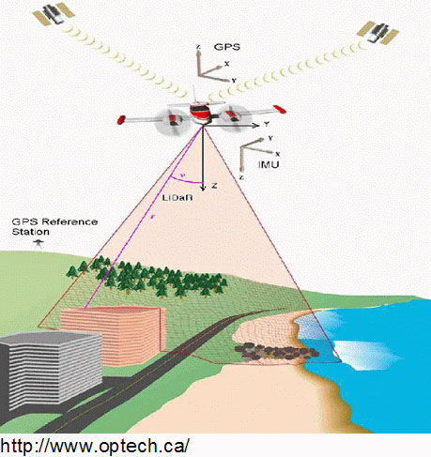
Figure 1: Principle: Airborne Laser Scanning (ALS, http://www.optech.ca/).

Since the mid 1990ies a rapid development in ALS system design can be observed. Next to advanced technologies for direct geo-referencing (higher GPS and IMU frequencies, advanced processing software, etc.), which allow a higher reliable and accurate direct geo-referencing of the sensor platform, a significant progress in laser scanner system design can be observed. While the first commercially available ALS systems allowed the range determination of one echo (either the first or the last echo, the setting was chosen dependent on the application) only, current systems allow to discriminate and store multiple echoes per emitted laser pulse (first, last and intermediate echoes, cf. Pfeifer et al., 2007). This is especially interesting in wooded areas where one might be interested in vegetation as well as terrain echoes.

The newest generation of ALS sensors, the so-called full-waveform scanners, even provide further information about the reflecting surface elements, due to the storage of the entire received echo (cf. Hug et al., 2004 and Wagner et al., 2006). Typically, these systems digitize the received waveform with an interval of 1ns. This ability allows to apply echo detection and modelling algorithms, depending on the individual application in post processing. Furthermore, these echo analysis allows to extract further interesting information about the reflecting object surface which can be used in subsequent processing steps (cf. Doneus et al., 2006). Additionally, apart from to the echo determination, a significant increase in the pulse repetition rates (PRR) of the ALS sensors can be observed. While the first systems just allowed to emit a few thousand laser pulses per second, current systems have a PRR of more than 100 000 pulses per second. This increase leads to a much denser sampling of the landscape, allowing a much more detailed reconstruction of the topography. Additionally, the ranging domain of the ALS systems have increased significantly - starting from a few meters up to several thousands of meters. This higher spectrum makes ALS much more flexible and interesting for different applications, from DTM determination of small project areas (just a few square kilometres), corridor mapping using low flying heights, to countrywide data acquisition.

Apart from the developments in the ALS sensor hardware, the processing software for the individual processing steps improved rapidly. For a high quality geo-referencing of the data, apart from developments in direct geo-referencing, strip adjustment techniques allowing a higher relative and absolute geo-referencing of the ALS data have been developed (e.g Burman, 2002, Filin, 2003 and Kager, 2004). Furthermore, a lot of different methods for the automated generation of digital terrain models (DTMs, including classification procedures of the acquired ALS point cloud into terrain and off-terrain points) have been developed as well. A comparison of several methods can be found in the paper by Sithole et al. (2004). Next to DTM determination, algorithms for several other application fields, such as city modelling (cf. Hyyppä et al., 2005), power line extraction and modelling (Melzer et al., 2005), vegetation mapping (Hyyppä et al. (2004)), etc., were developed. Nowadays, ALS is used for a lot of different applications.

3 Airborne laser scanning campaign Vienna 2007
In 2006 the surveying group of the Vienna City Administration (Municipal Department MA 41, http://wien.gv.at/stadtentwicklung/stadtvermessung/) ordered an ALS flight of the whole area of the city of Vienna (approx. 450km², city with its surrounding). The project is currently carried out by the company Diamond Airborne Sensing (http://www.diamond-air.at/airbornesensing.html) operating the full-waveform ALS Sensor Riegl LMS-Q560 (http://www.riegl.com/airborne_scannerss/lms_q560_/q560_all_.htm). The flying height of the data acquisition campaign was about 500m above ground using the maximum field of view of 60°. The overlap of neighboured ALS strips was higher than 50% which resulted in a very dense data set with more than 10 points/m². For the whole project area, full waveform information will be available.

Currently the processing of the data (fine geo-referencing, generation of digital surface models (DSMs) and DTMs) is in its final stage. However, for this study only a pre-delivery of the data could be provided by the flight company. Therefore, we were only able to process a pre-geo-referenced version of the ALS data. The available data set was just geo-referenced with the help of direct geo-referencing methods. Due to that fact, we could observe in this pre-delivery some strip differences which will be reduced in the final delivery of the data by a fine geo-referencing approach. Therefore, an accuracy analysis of the data has to be done with care; nevertheless, the available data set has allowed us to study the potential of ALS data for the determination of very detailed DTMs.

4 Comparison of the different data sources

4.1 Used data sources
The used data sources for this comparison are, corresponding to Ditz et al. (2005), the orienteering map "Hadersdorf", the contour lines from the photogrammetric interpretation with an equidistance of 2 meters (shown in violet in all illustrations), the contour lines from the DTM derived from the laser scanning campaign in 1996 with an equidistance of 1 meter (shown in green), and the contour lines with an equidistance of 1 meter (shown in red), derived from the a DTM of the pre delivered data set of the ALS campaign in 2007 with a resolution of 1 point/m². For two parts of the area, contour lines with an equidistance of half a meter were derived from a higher resolution DTM (4 points/m²) of the laser scanning campaign 2007 (shown in blue). This higher resolution DTM was computed with a slightly reduced version of the data of just one strip (in order to discard relative geo-reference problems between the strips of the pre delivered data).

The illustrations from Ditz et al. (2005), with the photogrammetric interpretation on the left side and the laser scanning data from 1996 in the middle, were supplemented with the corresponding detail of the actual laser scanning data, shown on the right side (figures 2 to 5).

4.2 Comparison and discussion
The main morphological structures without any further terrain features like trenches, erosion gullies, or small land forms, have been already represented by the data from 1996. The smoothing on the top of the hill is realized in the actual data, as can be seen in figure 2. Only the post processing of the contour lines on the saddle area is capable of improvement.

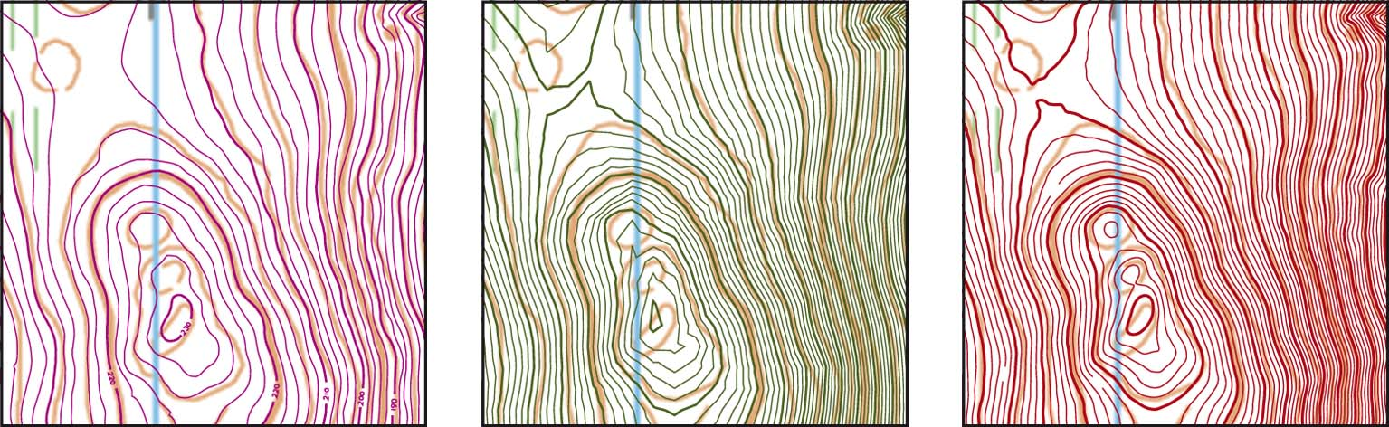
Figure 2: Main morphological structures in steep areas
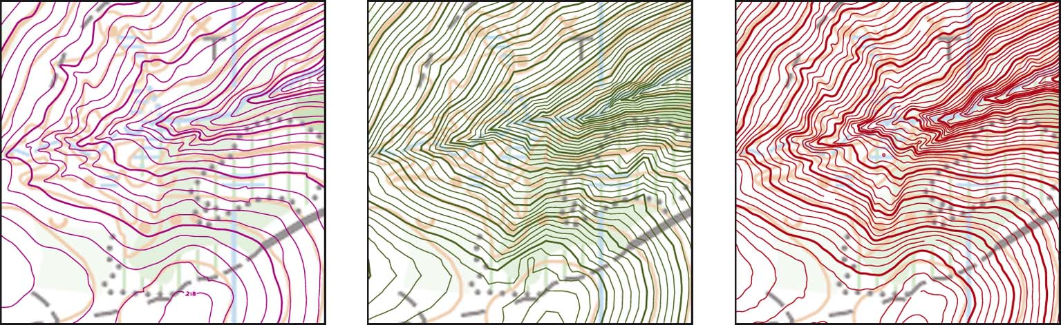
Figure 3: Small geomorphologic details

Terrain features from the data of 1996, which cannot be assigned to reality, like, for instance, the ridge in the eastern part south of the big trench of figure 3, are possibly caused by the lower resolution and errors in the classification of vegetation echoes. Figure 3 indicates already the improved quality of the contour lines, derived from the actual laser scanning data: the two small trenches north of the big trench are represented in a better way. However, one has to keep in mind that especially small terrain features always depend on the personal view and interpretation of the person doing the fieldwork, and that those terrain features, being represented by contour lines, are moreover emphasized for the orienteering map.

Figure 4 shows an example of erosion gullies and the approved derivation of contour lines from the new dataset. Even small erosion gullies are represented, which can be intensified by using a higher point resolution, for deriving the contour lines, as shown in figure 7. The special, not explainable phenomenon of the intersecting contour lines at the moderate inclined slope at the south-western part of this example could not be correlated with the actual laser scanning data.

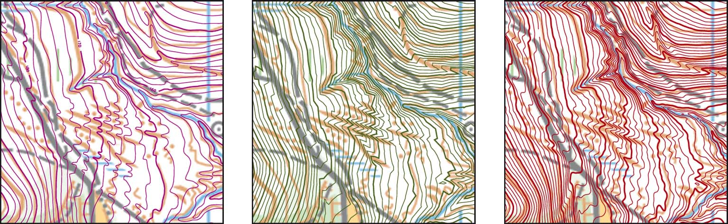
Figure 4: Small erosion gullies
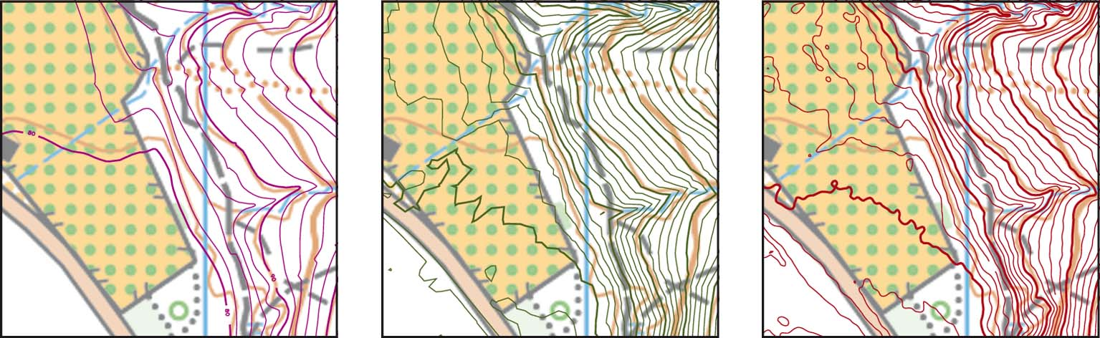
Figure 5: Contour lines in flat areas

The example of flat open land or rough open land shows that the higher density of points makes a smooth contour line impossible, as shown in figure 5, due to a higher accuracy in height and the noise of the rough ground. The small erosion gully in the north-eastern part of this example is slightly depicted, while the two hollows at the south, with a trail running through them, are not drawn-out distinctly of the actual laser scanning data, neither.

Figure 6 demonstrates the impact of a higher point resolution, shown by the example of DTMs. Due to a point resolution of 4 points/m², the details at the right side of this illustration are much more accurate, , than at the same part of the left side. Apart from the erosion gullies, roads down to footpaths can also be depicted from the DTM, as Attwenger et al. (2006) describes comprehensively. Good examples are the footpath at the south-east side and the vehicle track crossing from the south up to the western part of this illustration. Figure 7 shows the comparison of contour lines derived from different DTMs.

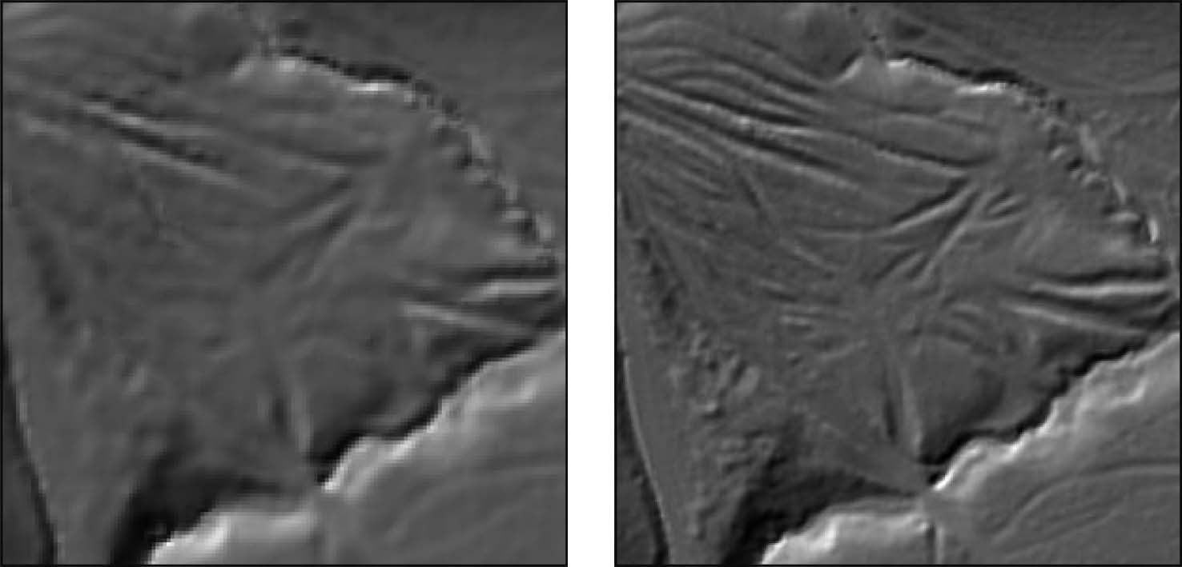
Figure 6: Comparison of digital terrain models with the resolution of 1 and 4 points/m²
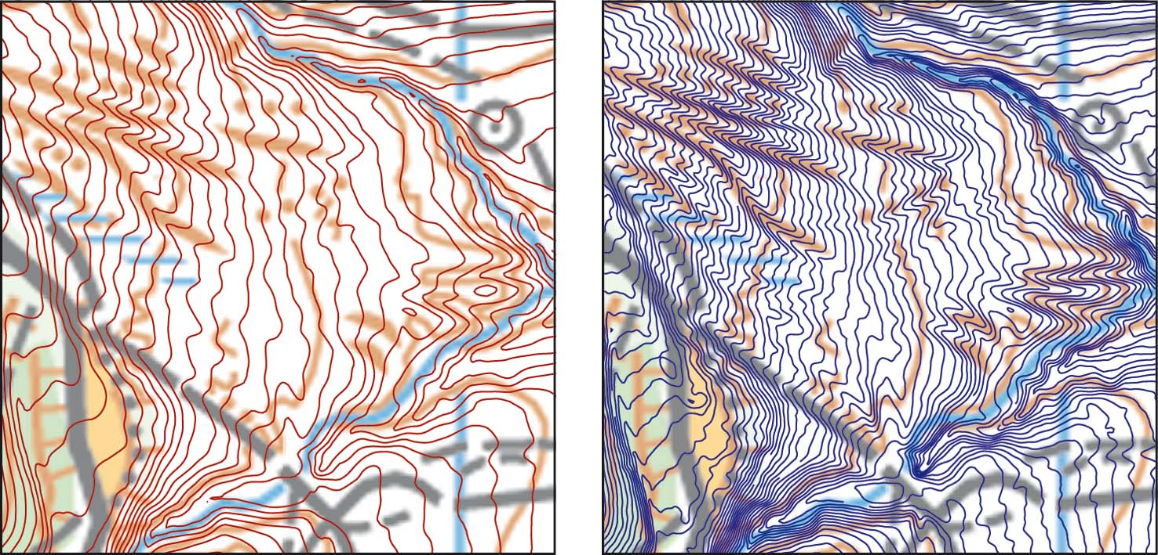
Figure 7: Contour lines derived from DTMs with different resolutions

The following illustration shows examples of the possibility to detect further elements related to the terrain, and to derive map features from the DSM. Figure 8a represents a combination of a DSM and DTM with contour lines derived from lower resolution data. This representation enables the extraction of quarries and cliffs. Furthermore, the use of the DSM offers the potential to detect special vegetation features, like single trees, without using a supplementing orthophoto.

Figure 8b shows the DTM of the higher resolution data set of the ALS campaign 2007 with three noticeable depressions, represented by contour lines. This figure also illustrates once more the capacity to detect trails and footpaths from the terrain model, as represented in the north-western part and close to the southern depression.

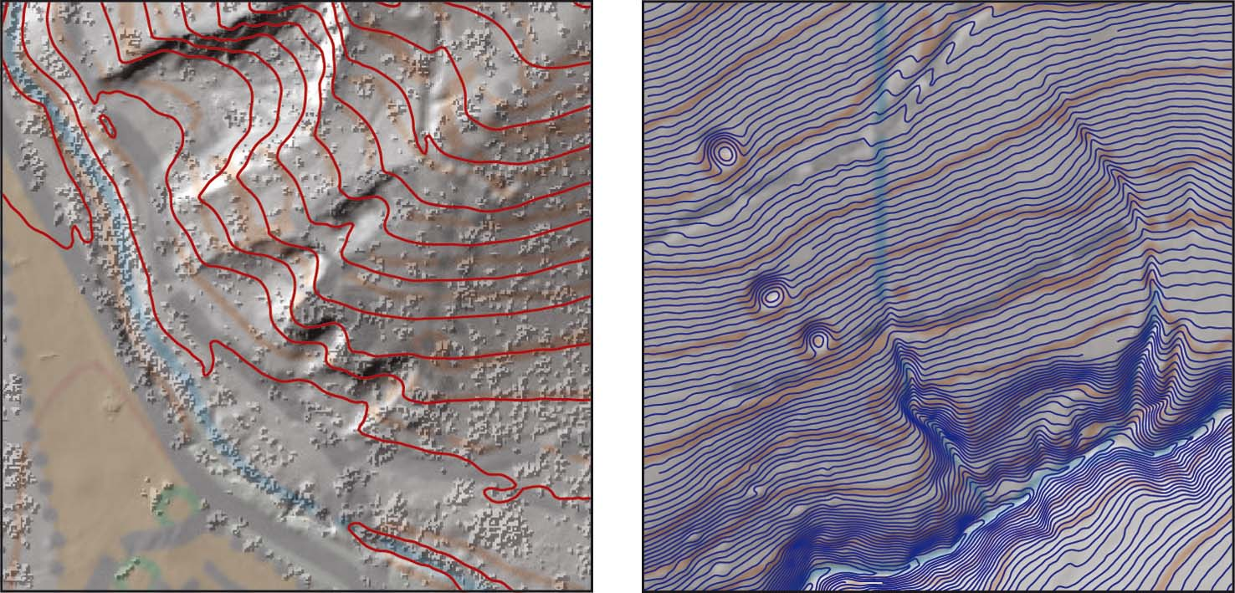
Figure 8a and 8b: High resolution DSM and DTM

5 Outlook
The latest developments in laser scanning (increasing point density, accuracy, etc.) have made this technology an interesting technique for data acquisition as a fundament for deriving and producing orienteering maps. The growing demand of ALS data and the increasing number of companies providing ALS data reduced the prices for those products in the last years. It can also be supposed that the achieved quality of ALS data will reduce the applied time used for fieldwork.

Further investigations have to be made to derive further topographic elements and map features from laser scanning data. For the future work, it would be interesting to try to develop algorithms which allow the detection of different classes of runnability of vegetation. Considerations on that topic are in progress.

References
Attwenger, M.; Kraus, K. (2006): Aufnahmen flugzeuggetragener Laserscanner als Grundlage zur Erfassung von Straßen und Wegen in bewaldeten Gebieten. In: Mitteilungen des Bundesamtes für Kartographie und Geodäsie. Band 36, Arbeitsgruppe Automation in der Kartographie, Tagung Wien 2005.

Burman, H. (2002): Laser Strip Adjustment for Data Calibration and Verification. International Archives of Photogrammetry and Remote Sensing, Vol. 34/3, Graz, Austria.

Ditz, R.; Gartner, G. (2005): Applying Laser scanning as a basis for deriving orienteering masp of Vienna. In: Proceedings 22th Int. Conference of the ICA, A Coruna 2005.

Doneus, M.; Briese, C. (2006): Digital terrain modelling for archaeological interpretation within forested areas using full-waveform laserscanning. In: M. Ioannides, D. Arnold, F. Niccolucci and K. Mania (Editors), The 7th International Symposium on VirtualReality, Archaeology and Cultural Heritage VAST.

Filin, S. (2003): Recovery of systematic biases in laser altimetry data using natural surfaces. Photogrammetric Engineering & Remote Sensing, 69.

Hug, C.; Ullrich, A.; Grimm, A. (2004): LITEMAPPER-5600 – A waveform-digitizing lidar terrain and vegetation mapping system. International Archives of Photogrammetry, Remote Sensing and Spatial Information Sciences, Vol. 36, Part 8/W2, pp. 24-29.

Hyyppä J., et al. (2004): Algorithms and Methods of Airborne Laser-Scanning for Forest Measurements. International Archives of Photogrammetry and Remote Sensing, Vol. 36/8W2, Freiburg, Germany.

Hyyppä J., at al. (2005): Accuracy of 3D city models: EuroSDR comparison. International Archives of Photogrammetry and Remote Sensing, Vol. 36/3W19, Enschede, the Netherlands.

Kager, H. (2004). Discrepancies Between Overlapping Laser Scanning Strips - Simultaneous Fitting of Aerial Laser Scanner Strips. International Archives of Photogrammetry and Remote Sensing, Vol. 35, Istanbul, Turkey.

Melzer, T.; Briese, C. (2004): Extraction and Modeling of Power Lines from ALS Point Clouds, Presentation: Austrian Association for Pattern Recognition (ÖAGM), Hagenberg; 06-17-2004 - 06-18-2004. In: "Proceedings of 28th Workshop", Österreichische Computer Gesellschaft, 47 - 54.

Pfeifer, N.; Briese, Ch. (2007): Laser Scanning – Principles and Applications. 3rd International Exhibition & Scientific Congress on Geodesy, Mapping, Geology, Geophisics, Cadaster GEO-SIBERIA 2007, Novosibirsk, Russia.

Sithole, G.; Vosselman, G. (2004): Experimental comparison of filter algorithms for bare-Earth extraction from airborne laser scanning point clouds. ISPRS Journal of Photogrammetry and Remote Sensing, 59.

Wagner, W.; Ullrich, A.; Ducic, V.; Melzer, T.; Studnicka, N. (2006): Gaussian decomposition and calibration of a novel small-footprint full-waveform digitising airborne laser scanner. ISPRS Journal of Photogrammetry and Remote Sensing, 60, pp. 100-112.

Wehr, A.; Lohr, U. (1999a). Airborne laser scanning - an introduction and overview. ISPRS Journal of Photogrammetry & Remote Sensing, 54.

Wehr, A.; Lohr, U. (Editors) (1999b): Theme Issue: Airborne Laserscanning. ISPRS Journal of Photogrammetry & Remote Sensing, 54.

Acknowledgement:
The authors thank the Vienna City Administration, Municipal Department 41 for providing the ALS data for this publication.

